SRS DOCUMENT

**Submitted to:**

Prof. Lydia Jane

**By-**

Suraj Rishi (12BCE0210)

Saxam Trikha (12BCE0003)

**Objective:**

We aim to create an amusing website for promoting awareness and conservation of India’s wildlife. Apart from arousing the awareness it will posses detailed information on various rare Indian animals along with coverage of all species of animals that roam in the woods of INDIA. With this, it will act as a platform for wildlife conservationists and ecologists to share their knowledge and recent trends in this field. It will incubate research and participation on subjects like animal communications, habitats, wildlife health issues, effects of global warming and various disasters.

**Background Information:**

* The exploitation of land and forest resources by humans along with hunting and trapping for food and sport has led to the extinction of many species in India in recent times.
* In order to overcome the result of human encroachment many national parks as well as protected areas have been established.
* To further improve the situation, government as well as non-government organisations have launched various projects, organised camps, meetings to create awareness among the mass.

This website of ours will be a step further in this direction.

**Stakeholders:**

* Anonymous users
* Group members (registered users)
* Government and private organizations, Wildlife conservationist, ecologists, veterinarians and wildlife enthusiasts.
* Site administrators.

**Requirements:**

**Functional Requirements:**

* Anonymous access to the website.
* Provide users with option to register themselves.
* Users- Log in, post photos and information.
* Provide option for donation to various NGO’s.
* Top Stories.
* News about camps, meetings etc.
* Newsletters.
* Gallery Access
* Information about Careers.

**User Stories:**

* To monitor statistics related to endangered species, jeopardized habitats, unbalanced ecosystems and unfavourable climatic changes.
* To facilitate members to form groups to organize local meetings, wildlife forums, periodicals and Wildlife camps.
* To provide a space for registered users to post interesting photos, videos and presentations on Indian Wildlife.
* Secure registration and profile management facilities for registered members and government and non-government agencies.
* To acquaint users with various career opportunities in the field of Wildlife, along with a list of universities offering Wildlife Degrees, fellowships and certifications.
* It will portray recent wildlife success stories with an opportunity for users to participate in Wildlife logs, forums, internships, conferences and other awareness programs.
* To set up a reviewer’s panel that will be responsible for solving various queries of website users.

**USE CASE DIAGRAM:**

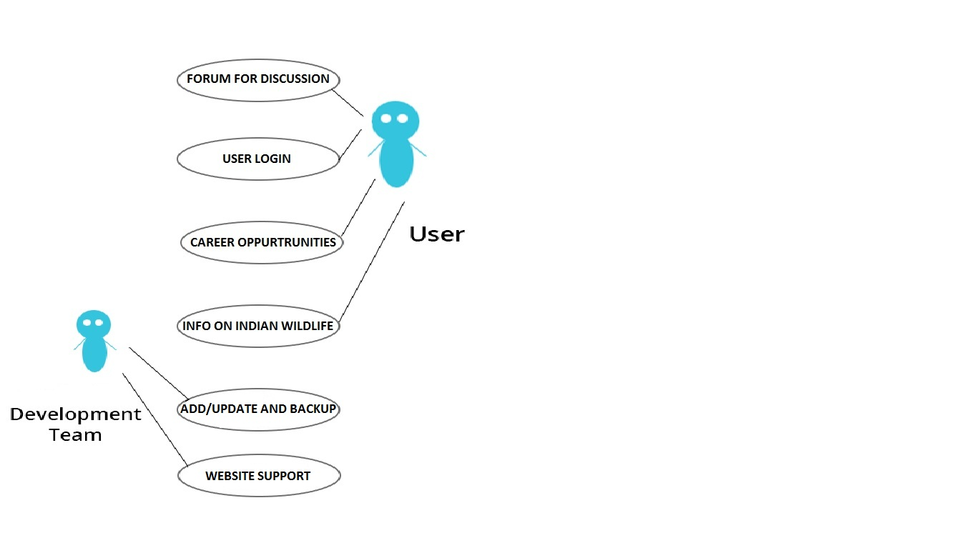

**Non-functional Requirements:**

* Accessibility: The website will be accessible to everybody, with no restrictions. The website can be accessed using any of the following browsers: Google Chrome, Mozilla Firefox and Internet Explorer (Version 8 and above).
* Security: The website will provide secure registrations to the users. No user details will be shared with a third party. The donations to non-profit organizations will be made through safe and secure gateways.
* Usability: The website will be attractive and user friendly. Graphical representation of Wildlife Surveys on species, climates, lands and ecologies will be provided for better understanding.
* Price: The website will have no registration fees of any kind. All the features of the website will be available to the user for free.
* Scalability: The website will be designed keeping in mind the needs of the user, better component design to get better performance at peak time. The website will have flexible service based architecture that will be highly desirable for future extension.